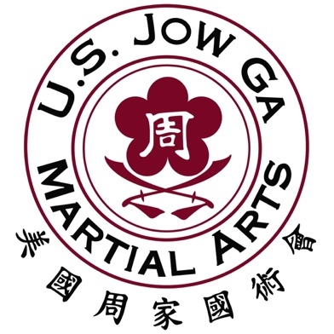
Intent to Promote Form

Student’s Name: __________________________

The instructors of USJGMA intend to promote this
student to his/her next rank in Martial Arts

It’s important for the instructor to know from an outside perspective HOW the student is demonstrating Kung Fu principles in regular every day life.
Friend/Teacher/Spouse/Parent’s Name: _________________________
Kindness: 5 4 3 2 1
Respect: 5 4 3 2 1
Loyalty: 5 4 3 2 1
Humility: 5 4 3 2 1
Honor: 5 4 3 2 1
Dicipline: 5 4 3 2 1

Please grade the student below using the grading scale.
5 – Excellent 4 – Does Well 3 – Neutral 2 – Needs Work 1 – Never Demonstrates

How to Submit this form:

Step 1: Take a pic of this paper

Step 2: Email it to us at “USJGMA@gmail.com”

Interested in being part of a growing community of martial artists dedicated to changing their lives through the achievement of physical and mental growth?

Complete the info here and we will reach out to you about scheduling a 1 on 1 FREE introductory lesson and strategy session at your convenience.

Name: _____________________________

Email: ________________________________

Phone Number: ______________________________

